
Create PAC Transfer
Local association EPOEs have the ability to create a free, safe and secure direct deposit (EFT) to transmit monies from the local association to the State Association for PAC.
The EPOE for the local association has access via a security class known as RPOE to a function on the main Ecommerce menu known as PAC EFT Transfer.
When the local EPOE logs in, if they have this security setting, they will see the function on the menu.
(all examples in this guide are test association and test accounts only).

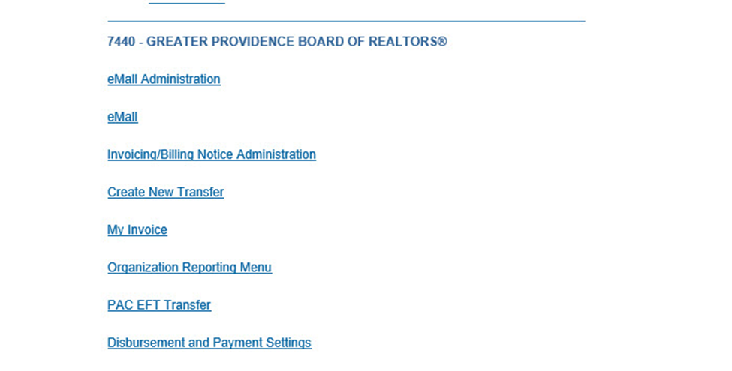

To begin, select the PAC EFT Transfer and the following will appear
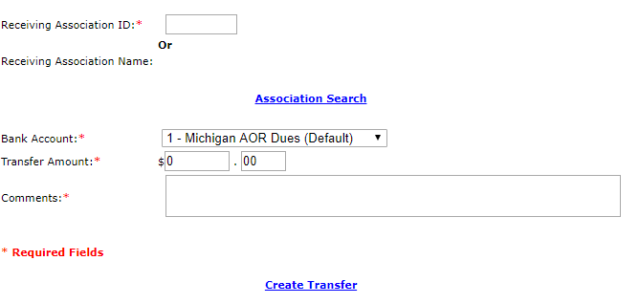
In the Receiving Association ID field enter the Association ID of the State Association (for Michigan, the Receiving Association ID is 842). This field will accept only a state association. You cannot send a PAC EFT to NAR or another local association.
Once you enter the Association ID, press your TAB button.
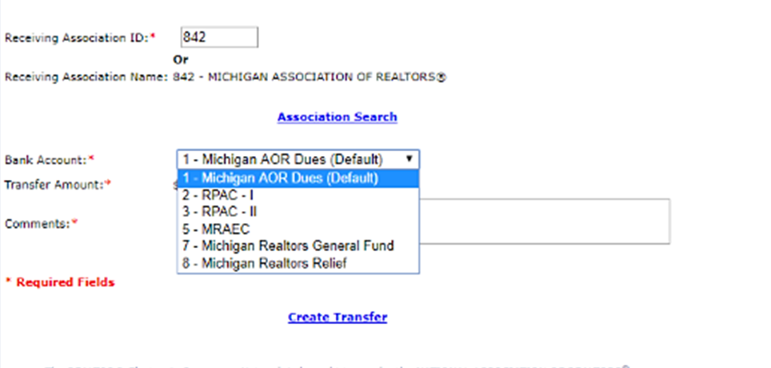
A drop-down list under Receiving Bank Account will appear for the state selected.
The Receiving Bank Accounts are:
2 – RPAC – I (Personal RPAC I)
3 – RPAC – II (Corporate RPAC II)

Please note: you do not want to use this function for sending dues monies to your State Association or National

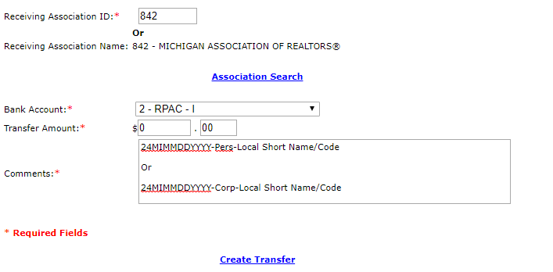
Once you have selected the Bank ID, fill in the amount and Comments. If as a local, you have more than one Bank ID the Sending Association’s Bank ID drop down box will still be there as always

When done, click the Create Transfer link.
At this point you can choose to Delete and start over, click Change to change any of the data you entered or click Confirm Transfer to complete it and send it.
Once you click Confirm, just as with any EFT a receipt screen will appear. Print and save this for your records.
Once finished please send an email to rpac@mirealtors.com. In your email, please attach your upload spreadsheet and transfer receipt (see above) or cut and paste the receipt into your email along with your spreadsheet.

When the local runs their Group Summary report, you will see these EFTs along with any other EFTs you create in the Manual EFT section as always. And State associations will see these on their Group Summary under Manual EFT for the appropriate Bank ID.

